HONG KONG HOCKEY ASSOCIATION – WOMEN’S SECTION

COMPETITION BYE-LAWS

CONTENTS

1. Name
2. Definitions
3. Authority of HKHA Women’s Section Committee
4. Alteration to the Competition Bye-laws of the HKHAWS
5. Teams
6. Player Registration
7. Visiting Players
8. Player Movement
9. Player Transfer
10. Team Uniforms
11. League Organisation
12. League Matches
13. Postponements/Cancellations/Abandonments
14. Captains’ Responsibilities
15. Match Cards
16. Domestic Tournaments
17. Misconduct, Complaints and Appeals
18. Responsibility of Teams to Provide Umpires
19. Advertising on Uniforms
20. Charges &Levies
21. Trophies
22. Unforeseen Events

SCHEDULES

First Schedule Fees
Second Schedule Penalties and Fines
Third Schedule Yellow and Red Cards
Fourth Schedule Advertising on Uniforms

- NAME

The Section shall be called the Hong Kong Hockey Association – Women’s Section, hereinafter referred to as “HKHAWS”.

- DEFINITIONS

The following words and expressions shall have the following meanings:

Affiliated Club A club, association or team that is affiliated to the HKHAWS.

Committee The Hong Kong Hockey Association Women’s Section Committee.

Committee Member An elected or co-opted member of the Committee holding the post of general committee member.

Office Bearer An Elected Member of the Committee holding the post of Chair, Vice Chair, Honorary Secretary, Honorary Treasurer, Registrar, Grounds & Fixtures Secretary, Tournaments Secretary, Umpires Secretary.

Club Convenor Person nominated by an Affiliated Club as the appointed representative empowered to communicate with the Committee.

Club Official Presidents, chairmen, secretaries, hockey convenors of affiliated clubs. In addition, persons who hold these posts in a hockey section of a multi-sports club are also designated club officials.

Team Official Includes captain, team coach, manager, assistant manager, trainer or doctor/ physiotherapist.

Umpire Those nominated or designated to umpire matches held under the auspices of the HKHA.

Match Official Those nominated or designated to officiate at matches held under the auspices of the HKHA

Disciplinary Committee The Disciplinary Committee appointed by the Hong Kong Hockey Association.

- AUTHORITY OF HKHA WOMEN’S SECTION COMMITTEE

In accordance with Article 15 of the Articles of Association of the Hong Kong Hockey Association and the General Bye-Laws of the Hong Kong Hockey Association Women’s Section (“HKHAWS”), all issues concerning women’s hockey in Hong Kong are under the sole authority of the HKHA Women’s Section Committee (“the Committee”).

- ALTERATION TO THE COMPETITION BYE-LAWS OF THE HKHAWS

  - The Committee shall have the power to make, amend or delete Competition Bye-laws for League, Cup, Festival and other Tournament matches as may be required from time to time. Clubs shall be given fourteen (14) days to comment on the proposed changes.

  - The Committee may also introduce experimental Bye-laws from time to time. Clubs shall be given fourteen (14) days to comment on the proposed changes.

  - The Competition Bye-laws, and any amendment, shall be submitted to and approved by the HKHA Council before implementation.

  - The Secretary shall furnish the Convenor of each Affiliated Club with a copy of the Competition Bye-laws of the HKHA within twenty-one (21) days of any changes.

- TEAMS

  - Affiliated Clubs of the HKHAWS may apply for one or more teams to be entered in the Women’s League. Each team shall have a minimum of eleven (11) registered players, and no more than thirty (30) players, who may be registered for one team. However, if a team registers more than twenty two (22) players, an administrative fee (as per First Schedule) shall be charged per player from the twenty third (23rd) player onwards irrespective of whether players are de-registered at a later date. A player may only be registered for one Affiliated Club team at any one time, but may also be a member of the HKHA Veterans Section or a Promotion and Development Section Team.

  - Multi-team Affiliated Clubs shall enter teams in the HKHAWS League, Cup, Festival and other Tournament matches in ranking order of A, B, C, D etc. The strongest team, based upon talent and experience of players therein, shall be the highest ranked and shall be called the ‘A’ team. The B, C, D, etc., teams shall follow generally in order of strength based upon the criteria for A team players. (It is acknowledged that there are circumstances when this general requirement may not be strictly followed. The HKHAWS shall monitor this aspect, and may, at its sole discretion, take disciplinary action against any Affiliated Club, which it believes to have abused the intention of this.)

- PLAYER REGISTRATION

  - Each Affiliated Club shall ensure that only registered hockey players of that club take part in hockey matches held under the auspices of the HKHA. A person shall not be considered for registration unless the HKHAWS Player Registration application form is correctly completed, signed and has the necessary supporting documentation. (This includes a copy of an HKSAR Identity Card or a receipt for the application of one.)

  - Visiting Players being registered in Premier Division must provide a “Letter of No Objection” issued by the national hockey association of the last country they played for.

  - New players that have not registered previously with the HKHAWS must provide a signed declaration which states that they are not currently serving any suspensions or under disciplinary action.

  - No player may be registered unless she has reached her twelfth (12th) birthday. Players who have not reached their eighteenth (18th) birthday on the first day of September in the then current HKHA League shall have the agreement of a parent or legally appointed guardian as specified in the Player Registration form.

  - All re-registering players must sign a declaration annually to indicate that all player details are correct and that players understand associated liabilities of playing hockey in Hong Kong.

Contravention

  - A penalty, as specified in the Second Schedule, shall be levied for a contravention of these Bye-laws.

- VISITING PLAYERS

  - Each Affiliated Club is permitted to register a maximum of three (3) players NOT in possession of a valid Hong Kong Identity Card per HKHA League team. These players are referred to as ‘visiting players’. An administrative fee (as per First Schedule) shall be charged per visiting player registered.

  - A visiting player shall only play for the team she is registered for within the club. In other words, the visiting player cannot move among teams within the same club. Each League team is permitted to list and play a maximum of two (2) visiting players in any HKHA fixture.

  - Visiting players are NOT eligible to play in the last two League matches of their registered teams, nor in any Cup or Tournament matches. However, these restrictions shall be lifted once the visiting player has played a minimum of three (3) matches for her registered team and the Club concerned is responsible to inform the Committee prior to the visiting player taking part in Cup or Tournament matches. No registration of visiting players shall be permitted between the first (1st) day of February and the end of the HKHA League.

  - A visiting player must play a minimum of three (3) matches in the season for her registered team. Should this not happen, penalties shall apply as per the Second Schedule.

  - Clubs or teams who have registered visiting players bear full responsibility for the conduct of these registered visiting players. The visiting player’s Club shall pay any fines levied as a result of any misconduct of a visiting player.

Contravention

  - A penalty, as specified in the Second Schedule, shall be levied for a contravention of these Bye-laws. The HKHAWS will monitor the use of visiting players and reserves the right, at its sole discretion, to take disciplinary action against any club found abusing the privileges of Bye-laws 7.1-7.5 inclusive.

- PLAYER MOVEMENT

  - No player, even if she does not actually take part in the earlier match, may play for more than one team on any one match day, including goalkeepers playing outfield.

  - Each player shall be registered for one specific team which she plays as her designated team. A player:

    - who has registered for a higher-ranked team cannot play for a lower-ranked team without first obtaining the approval of the Committee.

    - who has registered for a lower-ranked team may only play for a higher-ranked team for a maximum of three (3) matches during the same HKHA League. This includes League, Cup and Knockout Tournament matches but excludes one-day divisional tournaments. Once she has played four (4) matches for higher-ranked teams, she will be automatically registered for the highest-ranked team that she has played for.

    - who has registered for a lower-ranked team is deemed to be automatically registered for the highest ranking team she has played for once she has played two consecutive games for a higher ranked team.

  - No player movement is allowed between any team in the Premier Division and the lower-ranked teams in their respective club until both (or more) teams involved have completed their first two (2) matches of the HKHA League. For the avoidance of doubt, this provision does not apply among teams outside the Premier Division.

Player Movement in Knockout Competitions

  - A lower-ranked player may play for a higher-ranked team in the Knockout Tournament competition, subject to compliance with Bye-law 8.2.2.

  - Once a player has participated for a team in one of the Knockout Tournament competitions, she cannot play for any other team in any Knockout Tournament competition thereafter.

Contravention

  - A penalty, as specified in the Second Schedule, shall be levied for a contravention of these Bye-Laws.

- PLAYER TRANSFER

  - Should a player wish to transfer from one Affiliated Club to another during the HKHA League, the Club Convenor of the player’s current Affiliated Club shall release the player in the online registration system.

  - The Club Convenor for the Affiliated Club that the player is moving to should then apply to the HKHA to move the player profile within the online registration system to the new Affiliated Club.

  - Until registration has been approved and completed, including payment of the appropriate fee, as specified in the First Schedule, the player concerned shall not play hockey for either Club, in any match, held under the auspices of the HKHA. She may, however, play for an HKHA team.

  - Should the current Club refuse to release the player within a reasonable time, but in any case no longer than five (5) working days from the date of an official request from the Convenor of the player’s proposed new Club to the Committee, the player may appeal to the Committee for the transfer to be approved. In the event of such unreasonable delay, the Committee may manually release the player and require the player’s previous Affiliated Club to pay the transfer fee.

  - A player who requests a transfer for the second time within the same season shall need to seek approval from the Committee.

  - No transfer of players between Clubs shall be permitted between the first day of February and the end of the HKHA League.

- TEAM UNIFORMS

  - Clubs shall submit their team uniform designs for the Committee’s approval each year when they submit their league registration form. The colours of the first and second strips should be distinctively different for the shirt and the socks. Failure to do so will be considered as an incomplete registration and will therefore be subject to a late registration fee should the completed form not arrive before the deadline set by the Committee.

  - Teams shall play in the shirt, skirt and sock colours as stated on their HKHAWS application form and approved by the Committee.

  - Goalkeepers shall wear, over any upper body protectors, a shirt or garment of a colour different from that of their own team and of their opponent.

  - The Committee shall advise all Convenors of these colours before the start of the HKHA League. In the event of a clash of colours, the second-named team on the fixture, being the “away” team, shall change their shirts and/or socks. Teams should note that a clash of sock colours might occur even though there is no clash of shirt colours.

  - No Club may use white coloured socks for either their first or second strip and should refrain from including white in their socks design.

  - No team may use yellow as an official colour for its shirts. This colour is reserved for the exclusive use of the HKHA Umpires Section.

  - The HKHA logo is the official designation for the uniform of players and officials of the HKHA selected to represent the HKHA or Hong Kong at representative hockey matches. Affiliated Clubs shall ensure that their members do not display the HKHA logo on any item whatsoever unless with the express permission of the HKHA Council. The HKHA Council will view any breach of this Bye-law as a most serious matter.

  - A player may not participate in any League, Cup or Tournament match organised by the HKHAWS unless she is:

    - wearing a uniquely numbered shirt. The number shall conform to her Player Registration number and shall be clearly printed or sewn on the fabric itself at the back of the shirt and should meet the following requirements:
        - the colour should be in contrast to the shirt colour
        - the number should be in a distinctive filled (not outlined) figure(s)/font(s);
        - the size should be not less than 16 cm and not more than 20 cm in height on the back of the player/goalkeeper’s shirt;

    - wearing shin guards, properly tucked inside her socks; and

    - wearing suitable footwear (football boots with studs for grass pitch shall not be worn on artificial-turf pitches).

    - undergarments (such as leggings or long sleeved shirts) worn during matches should match adjoining playing kit colours as much as possible. If not, only solid white or black colours are acceptable. Players should be prepared to remove their undergarments if such undergarments are adjudged by umpires to be causing confusion to their umpiring work.

*Note: Players are advised to remove all accessories during matches to avoid causing injuries.

  - Team Captains in the Premier and First Divisions must wear a distinctive arm-band or similar distinguishing article.

Contravention

  - A penalty, as specified in the Second Schedule, shall be levied for a contravention of these Bye-Laws.

- LEAGUE ORGANISATION

  - The Hong Kong Hockey Association League Competition (the HKHA League hereinafter) for the HKHAWS normally comprises:
        - A Premier Division;
        - A First Division;
        - A Second Division;
        - A Third Division;
        - A Fourth Division; and
        - A Fifth Division.

  - The number of Divisions and number of teams playing therein may be varied by the Committee prior to the commencement of each HKHA League to take into account of prevailing circumstances at the time, such as number of new teams entered, old teams dropping out, capacity of hockey pitches available for League matches etc.

  - The HKHAWS may accept teams from the HKHA Veterans Section and HKHA Promotion and Development Section, to participate in the HKHA League. Such teams shall only be accepted on condition that they abide by all relevant HKHAWS Bye-laws. The Committee shall decide in which Division such a team shall play. The results of HKHA League matches involving these teams will count for all purposes, except that the final placing of these teams will be disregarded for purposes of determining the HKHA League winners.

  - New teams shall start in the lowest Division unless the HKHAWS decides otherwise.

  - New teams wanting to enter a higher Division must demonstrate to the Committee that the team has eight (8) or more players that have been registered for a team in the same division, or higher, in the preceding season. Such teams may be placed in that division as determined by the HKHAWS.

  - No new team will be accepted once the HKHA League has commenced.

Promotion and Relegation

  - Points for league matches will be awarded as follows:
        - Win: Three (3) points
        - Draw: One point

  - Where two or more teams have an equal number of points, they will be ranked according to the following criteria (in order):
        - Matches won
        - Goal difference
        - Goals for
        - Results between equal teams in the competition

  - The Champion teams in the First, Second, Third, Fourth and Fifth Divisions shall be eligible for promotion to the Premier, First, Second, Third, and Fourth Divisions respectively for the following HKHA League season.

  - The lowest ranking team in Premier, the First, Second, Third and Fourth Divisions may be relegated to the next lower division.

  - If there is still a tie (after taking into account Bye-law 11.8) between two or more teams competing for promotion, the teams shall be declared joint winners of that Division.

  - Notwithstanding Bye-laws 11.9 and 11.10, the Committee’s decision on the Divisional composition shall be final. The Committee’s decision will be communicated to clubs at the start of each hockey season, including the promotion and relegation criteria at the end of that season.

- LEAGUE MATCHES

  - All matches shall be played in accordance with the rules of hockey in the current edition of the Rulebook Outdoor (Rules of Hockey), as issued by the FIH unless otherwise notified by the HKHAWS.

  - All matches shall commence at the scheduled time as stated in the fixtures list. In the event of a late start (i.e. after ten minutes of the scheduled time) where the fault lies with one or both teams (e.g. late completion of result card, goalkeeper not ready etc.) the umpire shall record this on the Match Card. The match playing time may be cut short into two equal halves in order for the next game to start on time or for the pitch to be handed over in time to LCSD for the next booking. This has to be communicated by the umpires to the team captains at the start of the match.

  - Should the entire team, for whatever reason, walk off (or refuse to continue to play), the match shall be awarded to its opponents four (4) goals to nil, or the score at the time, whichever is the higher.

Regular 11-a-side Matches

  - Teams shall, at the start of a match, consist of at least eight (8) registered players. In the event that a team (or teams) does not have at least eight (8) players on the field of play within ten minutes of the scheduled time for the start of the match, such team (or teams) will be in breach of this Bye-law, the match will not be played and the umpires will record the result as a WALKOVER on the Match Card. The team receiving the walkover will be awarded the game four (4) goals to nil.

  - In any regular competition (11 players on the field), if for any reason, the number of players of a team is reduced to less than eight (8) players, at the time that happens, the match shall be awarded to the opponents four (4) goals to nil, or the score at the time, whichever is the higher. The umpires will report the reason for the above, and if there is any question of players walking off, as opposed to injury or dismissal (red card), the matter will be referred to the Committee. For the avoidance of doubt, a player who has been shown a Yellow Card continues to be a player. A player who has been shown a Red Card immediately ceases to be a player.

Walkovers/Withdrawals

  - A team which gives two (2) walkovers during the HKHA League may be required to withdraw from the League by the Committee. In the event of such a withdrawal all previous results of that particular team will be nullified. The Convenor of a Club which has given a walkover in any HKHA match is required to explain in writing to the Committee, within seven (7) days of the date of the match, the reason(s) for the team having given the walkover.

  - If a team withdraws from the HKHA League at any time, the Committee shall have discretion to impose such penalty on that particular team as they deem necessary.

Contravention

  - A penalty, as specified in the Second Schedule, shall be levied for a contravention of these Bye-laws. Note that different penalties apply to different contraventions.

Request for Postponement or Bringing Forward of Matches

  - Requests for postponement or bringing forward of match on the grounds of player unavailability will normally not be entertained. The Committee may consider a request for postponement or bringing forward of match if the request is made at least fourteen (14) days before the match is scheduled to take place. The Committee will advise the Clubs within five (5) days whether their application has been granted. Requests for postponement or bringing forward shall be accompanied by an administrative levy, as specified in the First Schedule, which may be refunded at the Committee’s discretion.

  - Any match in which either team has three (3) or more players absent because of national team duty for the HKHA Squads (including as team officials) may be postponed upon request.

- POSTPONEMENTS/ CANCELLATIONS/ ABANDONMENTS

  - If an artificial-turf pitch has been inadequately watered (either by the spray system or naturally by rain), the umpires shall make a decision on whether the match shall commence. If the match is cancelled because of this, the umpires shall record this on the Match Card.

  - To be acceptable for play, the playing surface shall have received sufficient water to be thoroughly wet, taking account of the prevailing weather conditions.

  - The two teams shall not play a “friendly match” on the surface. If they do, they will not be protected by any insurance and the players will be at their own risk doing so.

  - In the event that a black rain storm signal or a typhoon signal Number 8 or above is in force at the appointed starting time, the match shall not commence.

  - In the event of a thunderstorm warning, and the authorities in charge of the pitch have not closed it, play shall commence/continue until the conditions are not safe for players and officials to stay outdoors. At that point the umpires shall temporarily stop the match (noting the time remaining) and all players and officials shall immediately leave the pitch area to seek shelter. When the storm has passed (and if permitted by the ground authorities) the match shall be restarted as directed by the umpires, taking account of the play situation at the moment of stoppage.

  - In the event that heavy rain causes an artificial-turf pitch to become so waterlogged that play becomes difficult or even dangerous, the umpires shall temporarily stop the match (noting the time remaining) and wait until the worst of the storm has passed and the pitch drained to a satisfactory condition. The match will then be restarted as per Bye-law 13.5.

  - For natural grass pitches, the decision on whether play may proceed rests with the venue’s authority. However, over matters of player safety, such as during a thunderstorm, the umpires shall take responsibility.

  - In the event of a failure of the floodlighting during an evening match, the umpires shall immediately stop the match. If the fault cannot be rectified within a short time, and the match restarted as per Bye-law 13.5, the Match Card shall be completed noting that the match was abandoned and the time remaining. The Committee shall then decide on the appropriate action.

  - The Club Convenor for the home team shall notify the Committee by telephone or email on the day following that on which League matches have been postponed or abandoned due to inclement weather. The Committee shall reschedule the playing of these postponed or abandoned League matches at the earliest opportunity.

  - Due to adverse playing conditions, the umpire may decide to abandon a match. Should the match be abandoned during the first half, the full match will be rescheduled to another time by Committee and NO score shall be carried forward to the rescheduled match. Red and/or Yellow cards issued will however be counted against the player’s disciplinary record. Should the match be abandoned after the completion of the first half, the score at the time will be counted as the final score with NO rescheduling of the match.

- CAPTAINS’ RESPONSIBILITIES

  - Each Team Captain has authority only over her own listed team players; she has no right to question or challenge any decisions made by the umpires. Should a match umpire call upon a Team Captain to give instructions to her team, the Team Captain shall do so immediately.
  - In the event that no umpires are present at the scheduled time for commencement of a match, both Team Captains shall act as umpires or may designate qualified individuals to act as umpires. Each Team Captain shall, therefore, have a whistle in her possession at each HKHA match. In the event that only one qualified umpire is present at the scheduled commencement of a match, it is the responsibility of the two Team Captains and the umpire to reach a mutually acceptable agreement as to the provision of the second qualified umpire. If this agreement is not forthcoming, each team shall provide one non-playing qualified umpire for one half of the match. In case either team or both teams cannot provide non-playing qualified umpire, the Team Captains have to either umpire for their respective teams or appoint one of their players who is qualified to umpire for the subject match.

  - Team Captains are responsible and held accountable for the completion and the accuracy of the information of their respective teams on the Match Card.

  - Team Captains are responsible for fielding her team with eligible players only.

Contravention

  - A penalty, as specified in the Second Schedule, shall be levied for a contravention of these Bye-laws.

- MATCH CARDS

  - The home team is the first named of the two teams in a match. Before the commencement of a HKHAWS match, the home Team Captain shall fill out a Match Card, in block letters, in ink or ball point, stating the particulars of the match (League, Division, Venue, Date, etc.), the names of all team players and their Registration Numbers, up to a maximum of sixteen (16) players. The completed Match Card shall be passed to the away Team Captain at least 15 (fifteen) minutes prior to the scheduled match start time.

  - On receipt of the Match Card, the away Team Captain shall fill in, in block letters, in ink or ball point, the names of all team players and their Registration Numbers, up to a maximum of sixteen (16) players. The completed Match Card shall be passed to the umpires at least five (5) minutes prior to the scheduled match start time.

  - The responsibility of checking the Team’s Players List and players’ ID Cards rests jointly with the officiating umpires and the Team Captains. In the event of dispute/disagreement between the two team captains, the officiating umpires shall make the decision and a note to that effect recorded on the Match Card.

  - Both Team Captains shall provide the umpires with photographic identification for all players listed on the Match Card at least five (5) minutes prior to the scheduled match start time. In the event a team is unable to produce photographic identification for particular players, the umpire should note which players were unable to produce photographic identification on the Match Card for action by the Committee.

  - In the event that an umpire fails to arrive at a match, the home Team Captain shall make a note of this fact on the Match Card.

  - After the match, the umpires shall record the final result on the Match Card, together with details of any Bye-law contravention and Yellow and/or Red Card awards. The umpires shall sign the card as a true record of the players taking part and of the result of the match, etc. and then both captains shall sign, before returning the Match Card to the Home Team Captain. Upon signing the Match Card, the team captain is deemed to have accepted the information recorded on the Match Card as accurate and final. Should one of or both captains disagree with the information on the Match Card, they should make note on the Match Card in the area provided and submit a written report to the Committee within three (3) days of the match.

  - The home Team Captain shall promptly post the Match Card to the HKHA office. An electronic copy may be sent to the HKHAWS office no later than three (3) days after the match should the Team Captain be unable to mail original Match Card in time, but the original Match Card must still be sent.

Contravention

  - A penalty, as specified in the Second Schedule, shall be levied for a contravention of these Bye-laws relating to the Match Result.

- DOMESTIC KNOCKOUT TOURNAMENTS

  - The tournaments approved by HKHAWS include the Knockout Tournament (Holland Cup, the Knockout Cup – whose derivatives are the Knockout Cup, Knockout Plate, Knockout Bowl and Knockout Saucer), one-day and other tournaments as sanctioned by HKHAWS from time to time.

  - Unless otherwise specified, all teams (except HKHA teams) are automatically entered into domestic tournaments organized by the HKHAWS. Teams may notify their withdrawal from these tournaments to HKHA Women's Section Commitee no later than 15 days (or at a date specified by the Committee) before the start of the respective tournament. Late withdrawal will be subject to a fine.

  - The normal rules of hockey and these Bye-laws shall apply to all tournaments except as per the following Bye-laws.

Knockout Tournament

  - The HKHAWS Committee shall determine which teams will take part in the Holland Cup and Knockout Cup competitions based on the team rankings at the end of the first round of the current HKHA League.

  - Convenors shall be advised in writing which competition they will take part in by the Committee.

  - The Committee shall work out fixtures for the competitions based on a draw of all the teams participating in each Tournament.

  - Seeding

    - Teams eligible for the tournament will be seeded by the Committee based on the team performances in the current Winter League.

    - The draw shall provide that the top four seeded teams in each tournament will not meet in the preliminary round.

    - The first seeded team will be at the top of the draw, the second seeded team at the bottom of the draw, the third seeded team at the top of the bottom half of the draw and the fourth seeded team at the bottom of the top half of the draw, and so on.

  - Conduct of Play

    - Unless otherwise advised by the Committee, matches will be thirty-five minutes each way, with an interval at half time of at least 5 minutes.

    - Current Premier Division rules shall apply to all Holland Cup games.

    - Each team is allowed to list and play up to sixteen (16) players in each Knockout Tournament match.

    - All players listed on the Match Card must provide photographic identification to the officials and umpires before the start of the match. Each player on the Match Card should be checked off upon implementation of the identification check.

  - Drawn Matches

    - In the event of a draw in all rounds up to and including the semi finals, the match winners shall be determined by a Penalty Shootout Competition. The Penalty Shootout Competition shall follow the Penalty Shootout Competition Regulations laid down in the current edition of the Rulebook Outdoor (Rules of Hockey), as issued by the FIH.

    - In the event of a draw in the final round, one period of extra time shall be played.

    - A period of five (5) minutes shall be allowed between the expiry of full time and the start of extra time.

    - Unless otherwise advised by the Committee, extra time shall consist of ten (10) minutes one way, and the first team to score a goal will be deemed to have won the match.

    - Should the scores be tied at the end of extra time, the match winners shall be determined by a Penalty Shootout Competition. The Penalty Shootout Competition shall follow the Penalty Shootout Competition Regulations laid down in the current edition of the Rulebook Outdoor (Rules of Hockey), as issued by the FIH.

  - Player Registration

    - Each team must submit their team list of up to twenty-two (22) players by a deadline set by the Committee. Players can be registered to ONE team only.

    - All players on the team list must be registered with the HKHAWS and have participated in at least two (2) League games prior to the submission of the Tournament team list.

    - Each team must register at least eleven (11) players who are currently registered with that team for the current HKHA League.

    - A player, once registered, may not play for any other team.

    - The following players may not be registered to play in the lower ranking team in the Tournament:

      - Players who are deemed to belong to the higher ranking team according to bye-law 8.2.2.
      - Players who have played in any of the last two League games of a higher ranking team

One-Day Tournaments

  - Format of play

    - The tournament shall be played in the format as designated by the Tournament Secretary or the Committee.

    - Round Robin:

      - If the format is in Round Robin format or include a Round Robin stage, points will be awarded as follows:

        - WINNER 3 POINTS
        - SCORE DRAW 2 POINTS
        - NO SCORE DRAW 1 POINT
        - LOSS 0 POINTS

      - If there is a tie at the end of the Round Robin stage, the ranking will be decided according to the following criteria (in order):

        - matches won
        - respective goal difference (i.e. goals for less goals against)
        - respective number of goals for
        - the result of the match played between those teams will determine the ranking of the tied teams

      - If there is still a tie after considering the above, a Penalty Shootout will be taken to determine the ranking.

    - Pool format:

      - If the tournament is played in two (2) Pools, the first stage will be single Round Robin (points and ranking will be determined as stipulated in Bye-law 16.11.2 (b) where the top two (2) teams of each Pool after the Round Robin stage shall enter into the semi finals as follows:

Winner of Pool A vs. Runner-up of Pool B
Winner of Pool B vs. Runner-up of Pool A

      - If there is a draw in a semi final, a Penalty Shootout will be taken to decide the winner.

      - The final will be:

Winner of semi-final (A) vs. Winner of semi-final (B)

If there is a draw in the final, a Penalty Shootout will be taken to decide the winner.

  - Penalty Strokes, Penalty Corners and Penalty Shootouts

    - Penalty strokes, penalty corners and penalty shootouts will be taken in accordance with the Regulations outlined by the current edition of the Rulebook Outdoor (Rules of Hockey), as issued by the FIH.

    - Penalty Shootout will be taken in accordance with the current FIH Tournament Regulations.

    - For 7-a-side tournaments, the defending team shall start with only four players (including the goalkeeper or kicking back) behind the back line at Penalty Corners. Subsequent numbers will be subject to the ‘breaking the line’ rule.

  - Teams

    - ‘hockey5s’
Teams shall consist of not more than ten (10) players, but not more than five (5) players of each team shall be on the field at the same time. Substitutions can be made at any time during the game and must be in accordance with Rule 2.3 of the current edition of the Rulebook Outdoor (Rules of Hockey), as issued by the FIH.

    - 7-a-side Tournaments
Teams shall consist of not more than eleven (11) players, but not more than seven (7) players of each team shall be on the field at the same time. Substitutions can be made at any time during the game and must be in accordance Rule 2.3 of the current edition of the Rulebook Outdoor (Rules of Hockey), as issued by the FIH.

    - 9-a-side Tournaments
Teams shall consist of not more than fourteen (14) players, but not more than nine (9) players of each team shall be on the field at the same time. Substitutions can be made at any time during the game and must be in accordance with Rule 2.3 of the current edition of the Rulebook Outdoor (Rules of Hockey), as issued by the FIH.

    - 11-a-side Tournaments
Teams will consist of not more than sixteen (16) players, but not more than eleven (11) players of each team shall be on the field at the same time. Substitutions can be made at any time during the game and must be in accordance with Rule 2.3 of the current edition of the Rulebook Outdoor (Rules of Hockey), as issued by the FIH.

  - Player Registration
    - A player, once played for a one day tournament for one division, may not play for the same one day tournament for another division.
    - The following players may not play in the lower ranking team in a one-day tournament:
      - Players who are deemed to belong to the higher ranking team according to bye-law 8.2.2.
      - Players who have played in any of the last two League games of a higher ranking team.
    - Players listed to play in a one-day tournament must provide photographic identification to the officials and/or umpires before the start of the tournament.

  - Duration of play

    - Pool matches, matches in Round Robin format and semi finals shall be twelve (12) minutes one way or as scheduled by the Tournament Secretary.

    - If the tournament is played in Pool format, the final shall be ten (10) minutes each way, with two (2) minutes allowed for change of ends or as scheduled by the Tournament Secretary.

  - All teams must be at the pitch at the designated time (usually half an hour before the first game) to complete the registration process and be ready for the start of the first game. Captains must hand in completed tournament registration cards to the Tournament Facilitator(s) prior the commencement of the first match in their Pool.

  - The tournament shall start on time and no grace period shall be given unless it is deemed necessary by the Tournament Facilitator(s).

  - Any team not showing up with a minimum of eight (8) players in the case of 11-a-side tournaments, a minimum of seven (7) players in the case of 9-a-side tournaments, a minimum of six (6) players in the case of 7-a-side tournaments and a minimum of four (4) players in hockey5s tournaments for their matches on time will forfeit their participation in the tournament and the results of their games will not be counted.

  - The first named team shall defend the north end of the pitch and shall have the push back, or in the final of a Pool format, the first push back.

  - Each team must provide umpire(s) according to the schedule issued by the Tournament Secretary or the HKHAWS.

  - In the event of a kit clash, the second named team must change to their full second strip or must change to their second strip shirt or their second strip socks, as necessary, to avoid any clash of colours.

  - The Tournament Secretary or the Tournament Facilitator(s) shall have the authority to arbitrate any disputes.

  - Where ‘hockey5s’ is played, the rules shall follow the current edition of the Rules of Hockey5s, as issued by the FIH, unless otherwise specified by the Tournament Secretary.

- MISCONDUCT, COMPLAINTS AND APPEALS

  - All officials, players and spectators participating in or at hockey matches held under the auspices of the HKHA shall be governed by the:

- The Rules of Hockey as from time to time made by the Hockey Rules Board under the authority of the International Hockey Federation (IHF);
- Rules of the HKHA;
- Bye-laws of the relevant Section of the HKHA; and
- The HKHA Code of Conduct.

  - All cases of misconduct shall be dealt with in accordance with Rules of the HKHA and/or Bye-law 15 of the HKHAWS General Bye-laws.

Yellow Card Penalty Points

  - A player receiving a yellow card shall receive penalty points as per Third Schedule.

Red Card Penalty System

  - A player awarded with a red card shall leave the field of play immediately (staying at the team bench is not permitted) and receive automatic suspension and penalty points as per Third Schedule.

  - All red card offences will automatically be investigated by the HKHAWS for misconduct and, where necessary, the case may be referred to the DC for further review. Suspensions received in the latter weeks of the season will carry forward if there are insufficient matches left to serve the suspension.

  - Complaints by an Affiliated Club against officials, players or spectators of another Affiliated Club shall be made, in writing, within forty-eight (48) hours, to the Secretary of the HKHAWS.

  - In the event that a player of:

    - an Affiliated Club is suspended from hockey, that player is automatically debarred from playing for her Club team as well as for any other HKHA team during the period of suspension. i.e. a two-match suspension means the next two (2) matches of the team for which the player was playing when the red card was awarded. The two-match suspension cannot be a combination of one Club match and one HKHA team match.

    - a HKHA team is suspended from hockey, that player is automatically debarred from playing for any HKHA team as well as for her Club team during the period of suspension. i.e. a two-match suspension means the next two (2) matches of the HKHA team for which the player was playing when the red card was awarded. The two-match suspension cannot be a combination of one Club match and one HKHA team match. If, during the period of suspension, her Club team has played two (2) matches, she may then play for her Club team even though she may still be suspended from playing for her HKHA team.

  - Other contravention of these Bye-laws shall be dealt with as specified in the Bye-Laws themselves, with reference to the Second Schedule, or by the Committee.

  - All appeals shall be dealt with in accordance with Rule 15 of the HKHA and/or Bye-law 16 of the HKHAWS General Bye-laws.

- RESPONSIBILITY OF TEAMS TO PROVIDE UMPIRES

  - Teams accepted for participation in HKHA matches shall be required, from time to time to provide umpires to officiate at matches allocated to them. It is the responsibility of such designated teams to provide properly registered umpires and to ensure that their nominated umpires turn up to officiate at matches so allocated.

Contravention

  - A penalty, as specified in the Second Schedule, shall be levied for a contravention of this Bye-Law.

- ADVERTISING ON UNIFORMS

  - Advertising in the form of a company’s name, logo or trademark is permitted when expressly authorised by the HKHAWS.

  - The size and positions of advertising follow the “2012 – Uniform Advertising Regulations” laid out in the FIH Regulations & Policies as issued by the FIH.

  - All measurements are taken as the area within a rectangle drawn around the advertisement. Permitted positions are as per the Fourth Schedule.

  - The prior written approval of the HKHAWS is required before a club can accept any sponsorship. The club is required to provide the HKHAWS with images or diagrams of the proposed advertisement(s) and await the approval of the HKHAWS before it enters into any sponsorship agreement.

  - Should an approval become out of date because a sponsor contract has expired, the club is not required to inform the HKHAWS. However, any changes to approved advertisement(s) or new advertisement(s) must be approved by the HKHAWS before use.

  - No advertisement will be permitted that is deemed by the HKHA to be detrimental to the positive image of the match.

  - The advertisement shall not in any way conflict with any code of ethics issued by the HKHA.

  - No tobacco or alcohol advertising shall be permitted with the exception of beer advertising which shall be permitted only in activities organised primarily for adults (e.g. Men’s, Women’s and Mixed leagues, Cup competitions and Tournaments). No beer advertising will be permitted in activities organised for young people under the age of 18 (e.g. Youth League, Mini Hockey).

  - No club may use the Hong Kong flag/national emblem unless permission/approval in writing from the Government regarding usage of the HKSAR logo has been sought and received. Any such approval should be submitted with the uniform design.

Contravention

  - Clubs contravening any of the above Bye-laws will be liable to a fine to be determined by the HKHAWS.

- CHARGES AND LEVIES

  - The Committee may, from time to time, be obliged to raise levies on teams and/or players registered with them.

  - Payment of any fees, disciplinary fines or levies should be made upon demand.

  - Invoices not paid one month after the due date will be subject to a penalty.

  - Teams or players with overdue fees, fines or levies may, at the discretion of the HKHAWS Committee, be excluded from active participation in any hockey event until such time as full payment, including any penalty added, is made.

Contravention

  - A penalty, as specified in the Second Schedule, shall be levied for a contravention of these Bye-laws.

- TROPHIES

  - All trophies won from any Leagues, Cups, Festivals or Tournaments organised by the HKHAWS shall remain the property of the HKHAWS.

  - Trophies shall be kept with HKHAWS or may be released to Affiliated Clubs on the condition that the trophies are signed out and returned upon request by the HKHAWS.

  - Once a trophy has been released to an Affiliated Club, the Affiliated Club shall take full responsibility for that trophy and will be liable for any cost incurred as a result of loss or damage to that trophy.

Contravention

  - A penalty, as specified in the Second Schedule, shall be levied for a contravention of these Bye-laws.

- UNFORESEEN EVENTS

  - Should circumstances arise which are not provided for in these Bye-laws, the Committee shall determine any actions necessary to deal with those circumstances.

- FIRST SCHEDULE

Bye-law 5.1 | Player Registration Fee | $300 per additional player if total registered players exceeds 22
Bye-law 7.1 | Visiting Player Registration Fee | $300 per player
Bye-law 9.3 | Player Transfer Fee | $300 per player per transfer
Bye-law 12.9 | Match Postponement / Bringing Forward Fee | $1,000 per request

SECOND SCHEDULE

Bye-law 6 | Unregistered Player | First contravention:  - forfeiture of match *  - deduction of one league point
Second contravention:
- forfeiture of match *
- deduction of three (3) league points
- fine of $500 per player per contravention
Subsequent contraventions:
- forfeiture of match *
- deduction of five (5) league points
- fine of $1,000 per player per contravention
Bye-law 7 | Unregistered Visiting Players | First contravention:  - forfeiture of match *  - deduction of one league point
Second contravention:
- forfeiture of match *
- deduction of three (3) league points
- fine of $500 per player per contravention
Subsequent contraventions:
- forfeiture of match *
- deduction of five (5) league points
- fine of $1,000 per player per contravention
 | Visiting Players | Forfeiture of all matches listing visiting player on Match Card
Bye-law 8 | Player Movement | First contravention:  - forfeiture of match *
Second contravention:
- forfeiture of match *
- deduction of one league point
- fine of $500 per player per contravention
Subsequent contraventions:
- forfeiture of match *
- deduction of three (3) league points
- fine of $500 per player per contravention
Bye-law 10 | Player Uniform | First contravention:  - $500 per player per contravention
Subsequent contraventions:
- $500 per player per contravention
- deduction of one league point

Bye-law 12 | Walk-Off / Refusal to Play | First contravention:  - forfeiture of match *  - fine of $500
Subsequent contraventions:
- forfeiture of match *
- deduction of one league point
- fine of $1,000
 | Walkover | First contravention:  - forfeiture of match  - fine of $500
Second contravention:
- forfeiture of match
- deduction of one league point
- fine of $1,000
Subsequent contraventions:
- forfeiture of match
- deduction of three (3) league points
- fine of $1,500
 | Withdrawal from the League | Penalty as determined by the Committee
Bye-law 15 | Late Submission of Match Card | First contravention:  - written warning from HKHAWS
Subsequent contraventions:
- deduction of one league point
- fine of $500
 | Non-receipt of Match Card Within fourteen (14) Days of a Match | Fine of $500 per contravention
 | Incomplete/ inaccurate Information on Match Card | First contravention:  - written warning from HKHAWS
Subsequent contraventions:
- deduction of one league point
- fine of $500
 | Failure to Provide Photographic Identification at Match to Umpires and/or Match Officials | Fine of $100 per player unable to provide photographic identification – up to a maximum of $800

Bye-law 16.2 | Late withdrawal from Domestic Tournaments | First contravention:  - fine of $1,000
Subsequent contraventions:
- fine of $1,500

Bye-law 16.8.4/16.14.3 | Refusal to Provide Photographic Identification at Match to Umpires and/or Match Officials | Forfeiture of match and automatic withdrawal from Tournament
Bye-law 18 | Failure to Provide Umpires | First contravention:  - deduction of one league point  - fine of $500
Subsequent contraventions:
- deduction of three (3) league points
- fine of $1,000
Bye-law 19 | Advertising on Uniform Without Approval | Penalty as determined by the Committee
Bye-law 20 | Late Payment of Charges and Levies | Penalty as determined by the Committee
Bye-law 21 | Lost Trophy | First offence: $500 per trophy lost plus the cost of replacing a similar style trophy  Subsequent offence: $1,000 per trophy lost plus the cost of replacing a similar style trophy

* In games where the match score is greater than 0-4 the higher result shall stand.

THIRD SCHEDULE

YELLOW AND RED CARDS

Yellow Card Penalty Points

A player receiving a yellow card shall also receive penalty points as follows:

Y1 Dissent (continued contesting of decisions) – one (1) point
Y2 Dangerous Play (violent stick tackle, violent obstruction) – three (3) points
Y3 Verbal abuse of Umpire or Player (use of foul language and continued and aggressive contesting of decisions with the umpires or between players) – three (3) points
Y4 Threatened assault on Umpire or Player (physical confrontation of the umpire or player by another player) – four (4) points
Y5 Others (state contravention)

If of a non-violent nature (repeated hitting away of the ball, repeated unsportsmanlike behaviour, continued and deliberate lifting of the ball) – one (1) point

If of a threatening nature (repeated contravention of a threatening nature that is not covered by the above) – four (4) points.

PENALTIES

4 points accumulated in one season – suspension for one match

8 points accumulated in one season – suspension for two (2) matches

12 points accumulated in one season – suspension for three (3) matches and referral to DC

Upon accumulation of four (4) points, the subject player will be immediately suspended for one match (League or Cup). Once the accumulated points exceed four (4) points (i.e. to five (5) or six (6) points), then once the player has completed her suspension, the player starts a new accumulation of points from four (4) to eight (8). The additional points above four (4) (i.e. one or two (2), depending on the total accumulated) shall begin to count towards the next “level” total of eight (8) points starting from five (5).

Example: A player, who has accumulated three (3) points, receives a yellow card with a code Y7 offence (4 points). The player now has accumulated seven (7) points. The player is automatically suspended for one match. Following the suspension, she begins to accumulate points in a new series of four (4) up to eight (8), starting at seven (7) points. Should the player accumulate a further point, she will be suspended for another two (2) matches.

Suspensions under the yellow card penalty points system shall be served upon the notification by the HKHAWS. Points left over from one season will not be carried over to the following season. However, suspensions received in the latter weeks of the season will carry forward to the following season if there are insufficient matches left to serve the suspension.
Depending on seriousness of each reported case of yellow card, the Committee may:

(a) take no further action, or
(b) issue a letter of warning, or
(c) interview and warn the player in person at a meeting; or
(d) refer the case to the DC should the offence bring the game of hockey into disrepute.

Red Card Penalty System

A player awarded with a red card shall leave the field of play immediately (staying at the team bench is not permitted) and receive automatic suspension as follows:

R1 Repeated Dissent – suspension for two (2) matches

R2 Second offense of dangerous play or very dangerous play – suspension for two (2) matches

R3 Repeated verbal abuse or foul abuse of umpire or another player – suspension for two (2) matches

R4 Repeated threatened assault or physical assault of umpire or another player – suspension for four (4) matches

R5 Others (state offence) – If of a non-violent nature: suspension for two (2) matches

If of a threatening nature – suspension for three (3) matches

FOURTH SCHEDULE

ADVERTISING ON UNIFORMS

Diagrams showing the positions allowed for advertisement

SHIRT (FRONT) SHIRT (BACK)
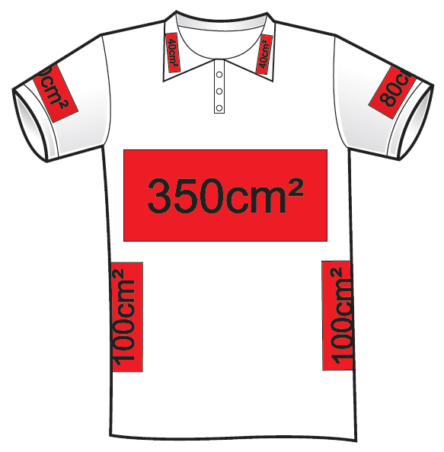
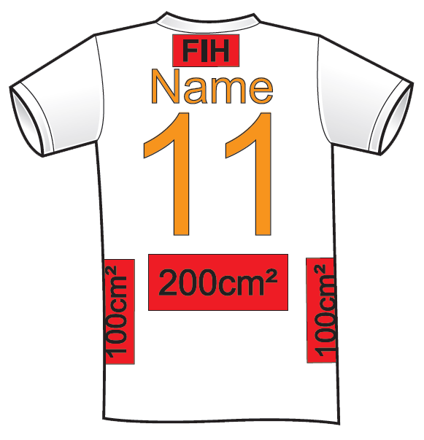
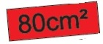

OR
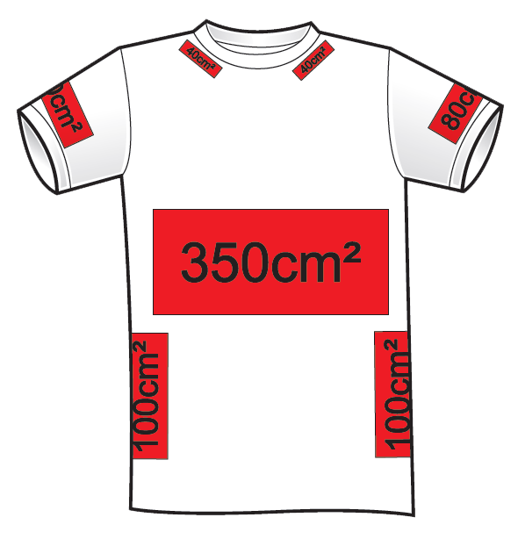
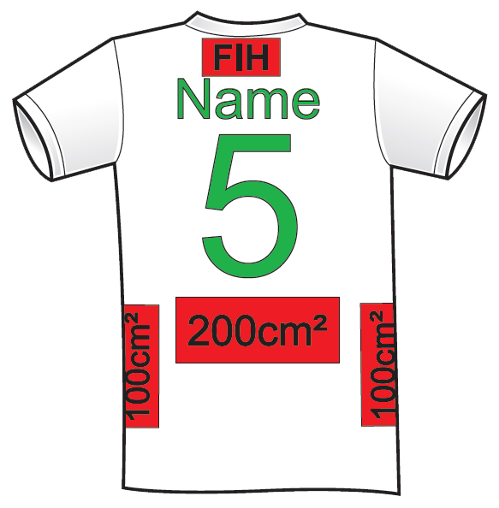

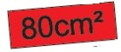

OR

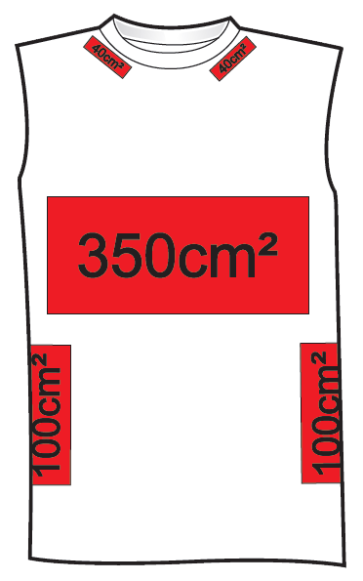
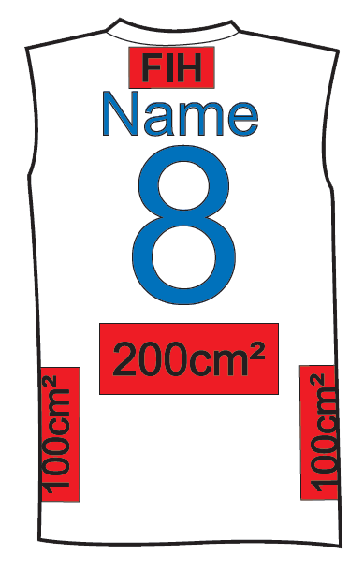

SHORT/SKIRT (FRONT) SHORT/SKIRT (BACK)

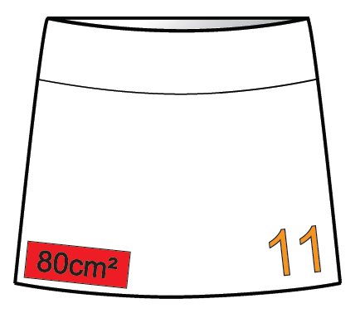
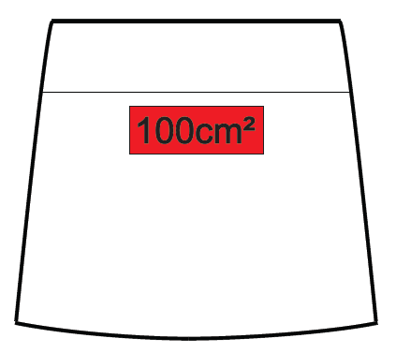

OR

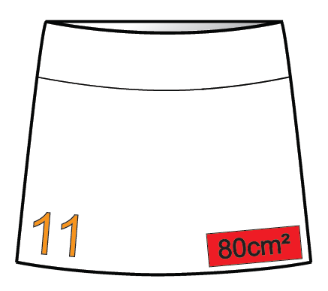

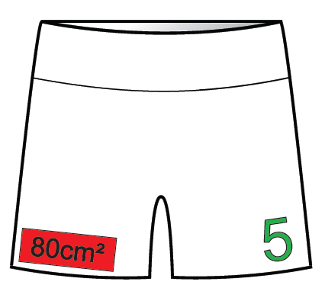
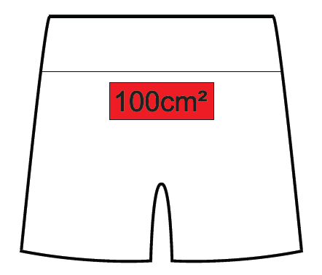

OR

